Single Click Access Manual
(ImageNow Full-Client Only)

Written By: Vonda Lee
December 2, 16

Introduction:

Accessing documents in ImageNow Full-Client is now just one click away. With a minor change to the ImageNow Application Plan, documents are visible by clicking the ImageNow icon located in your Desktop System Tray. This single click access functionality is available in ImageNow for Student ID, Vendor/Traveler ID, or Document Number entered in Banner.

Instructions to Set-up the Single Click Access Function:

- Login to the ImageNow full-client application. The ImageNow Toolbar should display on the monitor, as seen below:

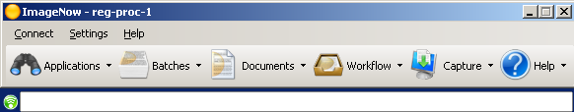

- Next, configure the ImageNow login session to use a default Application Plan. Select the SETTINGS option from the ImageNow Toolbar menu. Select OPTIONS from the drop-down menu, the ImageNow Options window should display on the monitor, as seen on the next page.

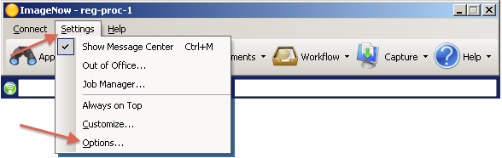

- On the GENERAL tab of the ImageNow Options window, select both SHOW SYSTEM TRAY ICON and ALLOW NOTIFICATIONS TO DISPLAY IN THE SYSTEM TRAY boxes in the SYSTEM TRAY section.

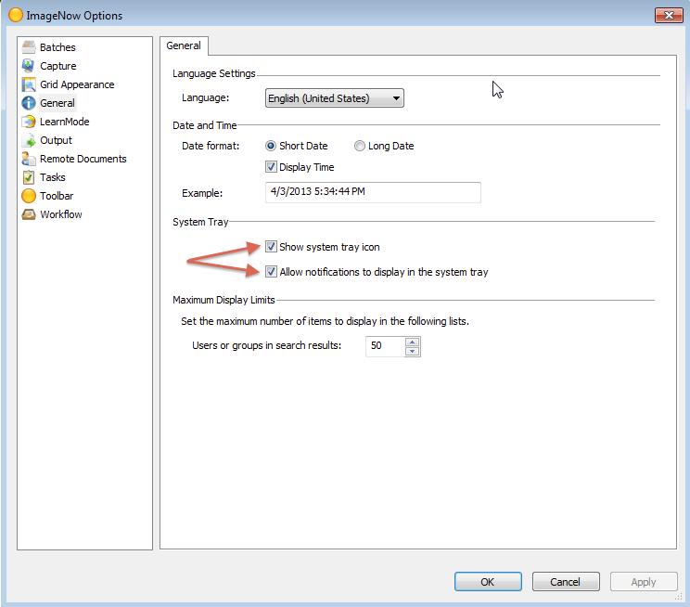

- In the left panel, click the TOOLBAR icon, click the DEFAULTS tab at the top of the window (as seen below), then click the desired APPLICATIONS under the DEFAULT ACTIONS section (select from the list below):
  - Registrar’s Office: REG Undergrad
  - Travel and Complex Payments Office:
    - TCP Assign ID
    - TCP Employee Taxable
    - TCP P-Card
    - TCP Travel Invoice
    - TCP Vendor Setup
  - Accounts Payable Office:
    - 49er Mart
    - AP Banner – FAIIVNE DPR
    - AP Banner – IDI
    - AP Banner – PO/DPR
    - AP Direct Deposit
- Click the OK button to save the changes and exit the ImageNow Options window.

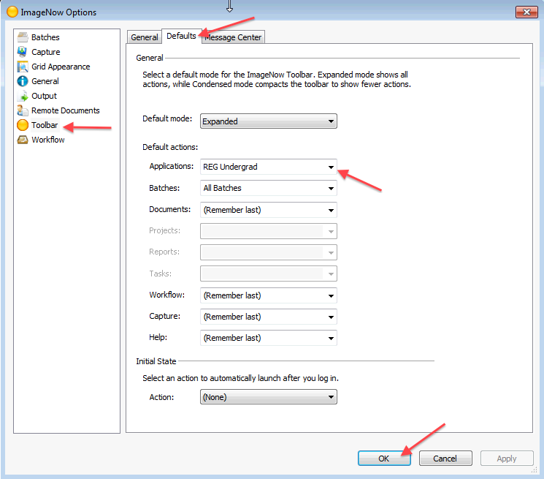

- Now, configure the ImageNow icon, which can be accessed in the Desktop System Tray. The Desktop System Tray is located in the lower right corner of the monitor near the time and date. Right click on the ImageNow icon as seen below:

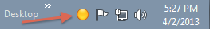

**Note: if you cannot see the ImageNow icon, click on the arrow to show hidden icons (to the left of all displayed icons). Click on the Customize link to open the icon appearance window. Select Show icon and notifications from the drop down menu under Behaviors for the ImageNow Icon and then click OK. The ImageNow icon will always show in the lower right corner on the monitor.

- Select OPTIONS, the ImageNow System Tray Options window should display on the monitor. Change the default action for the ON MOUSE CLICK to APPLICATIONS DEFAULT by using the drop-down menu option. Click OK to save and exit.

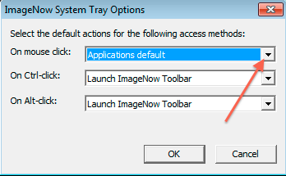

- Once you have completed both configurations above, you are ready now to use the Single Click Access method, Disconnect from ImageNow to save all the changes.

Using the Single Click Access Function:

- Log into ImageNow and Banner simultaneously, to view all documents pertaining to a Student ID, Vendor/Traveler ID, or Document Number.

- Select one of the following Banner forms that pertain to the actual task you are working on. Below is a list of available Banner forms that will work with Single Click Access for each department:
  - Registrar’s Office
    - SGASTDN
    - SFAREGS
    - SPACMNT
    - SAAADMS
    - SHATCKN
    - SMASADJ
    - SOAHOLD
    - SPAIDEN
    - SHATRNS
    - SPAPERS
    - SEADETL
  - Travel and Complex Payments
    - FTMVEND
    - FOAIDEN
    - FAIINVE
    - FGIDOCR
  - Accounts Payable
    - FAIINVE
    - FGIDOCR
    - GXADIRD

- Select one of the options below to view all documents pertaining to a Student ID, Vendor/Traveler ID, or Document Number:
  - Click the Desktop ImageNow Tray Icon
  - Or click the ImageNow binocular icon

  - Or click the APPLICATIONS drop-down menu button, as seen below, to select the desired application plan.

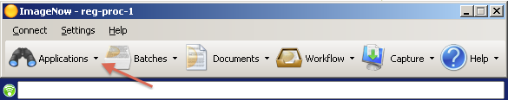

- The ImageNow Explorer window will display all documents available for the Student ID, Vendor/Traveler ID, or Document Number selected in Banner, as seen below.

